Postprocessor User's Guide for Nomura BN-130

Nomura BN-130 is a 3-Axis Milling Machine.

In order to use this postprocessor correctly, you should follow the instruction below.

1. UDE setting for quill-table positioning
Add Set Axis UDE to the operation or program group in the program order view. Set Axis to the axis you want to position. Once the ZAXIS is set to a location, the post will then only position in W. Likewise, if the WAXIS is set to a location, the post will then only position in Z.
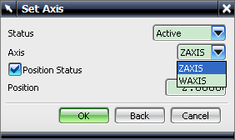
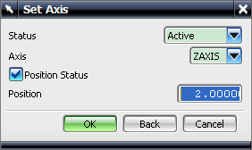

2. UDE setting for Z-W mode selection
Add the Set Modes UDE to the operation or program group in the program order view. Set Parallel Axis to the axis you want to output (Zaxis/Waxis).

